## What Our Clients Say



##### Sarah Johnson

CTO, TechCorp

"AI-Solutions transformed our workflow with their innovative AI implementation. Our productivity has increased by 40%."



##### Michael Chen

Director of Innovation, Future Labs

"The virtual assistant solution provided by AI-Solutions has revolutionized our customer service operations."



##### Emma Wilson

Head of Engineering, InnovateX

"Working with AI-Solutions has been transformative. Their solutions are cutting-edge and their support is exceptional."

### AI Virtual Assistant

Our AI-powered virtual assistant helps streamline customer service operations and internal processes. Available 24/7, it can handle inquiries, schedule meetings, and provide instant support.

* Natural language processing
* Multi-language support
* Custom training capabilities

### Workflow Automation

Automate repetitive tasks and streamline business processes with our intelligent workflow automation solutions. Increase efficiency and reduce human error.

* Process optimization
* Custom workflow design
* Integration capabilities

### Predictive Analytics

Leverage the power of AI to analyze data and predict future trends. Make informed decisions based on data-driven insights.

* Advanced data analysis
* Trend forecasting
* Real-time monitoring

### Employee Experience

Enhance employee satisfaction and productivity with our AI-powered employee experience platform. Create a more engaging workplace.

* Personalized learning
* Performance tracking
* Feedback automation

## Success Stories

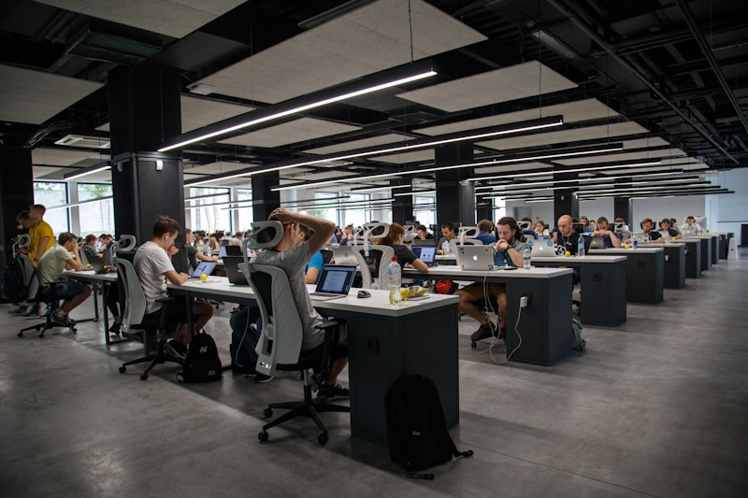

##### TechCorp Transformation

40% increase in productivity after implementing our AI Virtual Assistant solution.



##### Future Labs Innovation

Revolutionized customer service with 24/7 AI support system.



##### InnovateX Success

Achieved 60% faster project completion with workflow automation.

## Recent Events



##### Tech Conference 2025

Showcasing our latest AI innovations at the annual tech conference.



##### Innovation Workshop

Hands-on workshop with industry leaders exploring AI solutions.



##### Team Collaboration

Our team working together to deliver innovative solutions.

## Upcoming Events

##### AI Summit 2025

Join us at the biggest AI event of the year. We'll be showcasing our latest innovations.

London, UK  
September 15-17, 2025

##### Tech Meetup

Monthly meetup discussing the latest trends in AI and machine learning.

Sunderland, UK  
Last Thursday of every month

##### Innovation Workshop

Hands-on workshop exploring practical applications of AI in business.

Manchester, UK  
October 5, 2025